Influence of parameters

In this part, we aim to compare the effects of parameters Pf, Nf1, r1, r2, m1, m2 on biomass (N1, N2).

We take the theoretical value of each parameter as the mean value, and generate a normal distribution array under certain variance as the input of the growth system. At the same time, we change the growth time and observe the output. We choose coefficient of variation (CV) as the evaluation index, which can eliminate the influence of measurement scale and dimension, and compare the dispersion degree of each group of data.With smaller CV , the data is more stable and the influence of corresponding factor is less.

Formula: CV = STD / aver,where STD represents variance and aver represents mean value.

The results were as follows:

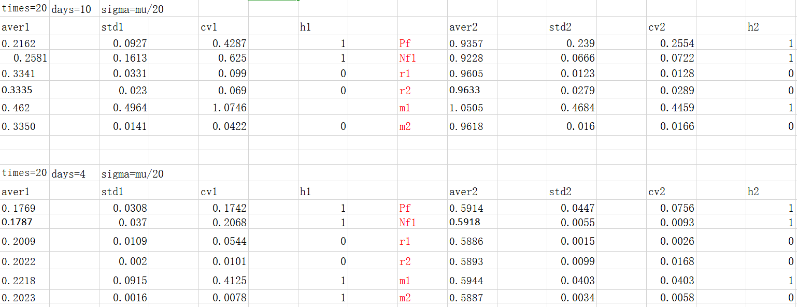

Through the analysis, we claim that under the condition of fixed growth time, the CV of m1, Pf and Nf1 is larger under the small disturbance, which indicates that these three parameters have the greatest influence on the growth of Nostoc sp. and Bacillus subtilis, while the CV of r1 and r2 is smaller and the influence is the least.

Here, we choose two cases to show:

1. Less stable ,greater influence of parameters with great CV:

m1 changes, times = 200, days = 10 ,CV1=1.0746,CV2=0.4459;

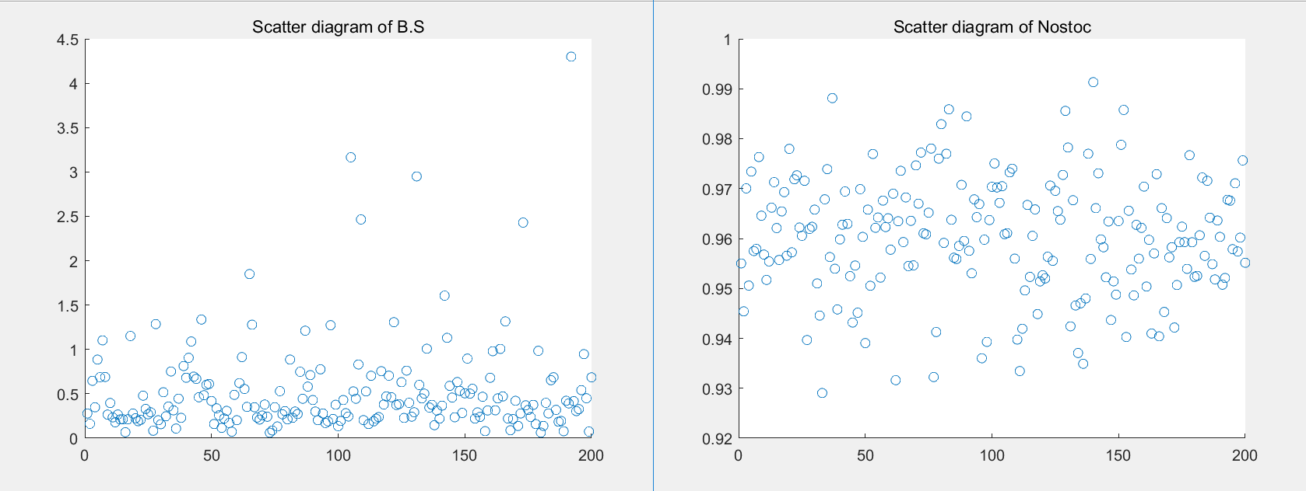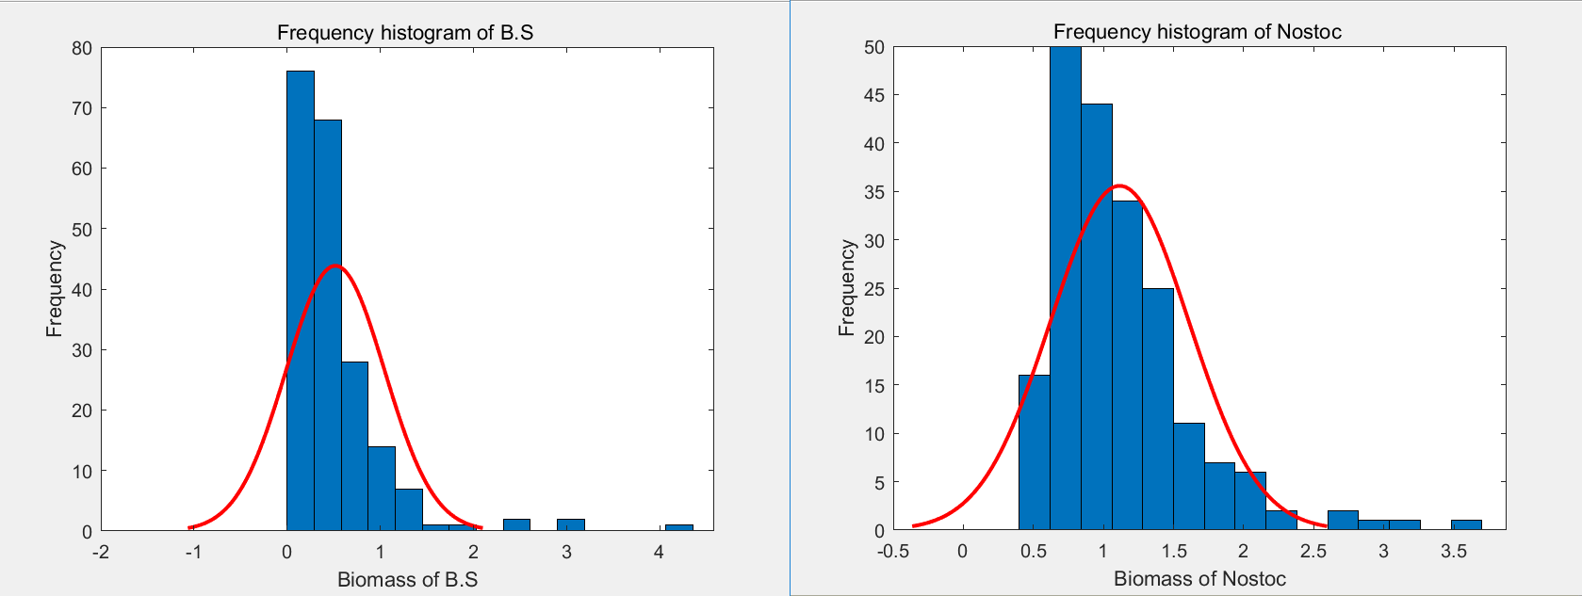

1. More stable ,less influence of parameters with small CV:

r1 changes, times = 200, days = 10 ,CV1=0.099,CV2=0.0128

